**Experiment NO :1**

Write a program to calculate the grade of a student to input five subject marks by user in Python.

AIM: Write a program to calculate the grade of a student to input five subject marks by user in Python.

Algorithms:

**Step1**. Take in the marks of 5 subjects from the user and store it in different variables.  
**Step 2**. Find the average of the marks.  
**Step 3**. Use an else condition to decide the grade based on the average of the marks.  
**Step 4**. Exit.

Program Code:

sub1=int(input("Enter marks of the first subject: "))

sub2=int(input("Enter marks of the second subject: "))

sub3=int(input("Enter marks of the third subject: "))

sub4=int(input("Enter marks of the fourth subject: "))

sub5=int(input("Enter marks of the fifth subject: "))

avg=(sub1+sub2+sub3+sub4+sub4)/5

**if**(avg>=90):

**print**("Grade: A")

**elif**(avg>=80&avg<90):

**print**("Grade: B")

**elif**(avg>=70&avg<80):

**print**("Grade: C")

**elif**(avg>=60&avg<70):

**print**("Grade: D")

**else**:

**print**("Grade: F")

**INPUT:**

Enter marks of the first subject : 70

Enter marks of the second subject : 85

Enter marks of the third subject : 78

Enter marks of the fourth subject : 91

Enter marks of the fifth subject : 88

OUTPUT: Grade: B

Result: Program is executed Successfully.

**Experiment NO :2**

Write a Program to input any number from user and check it is Prime no or not in Python.

Aim: Write a Program to input any number from user and check it is Prime no or not in Python.

**Algorithm**:

**Step1.**Begin by taking a number as input from the user.

**Step2**.Then, start counting through natural numbers, beginning at 2.

**Step3**.Check whether the input number can be divided evenly by any of these natural numbers

**Step4**.If the input number is divisible by any of these numbers, it is not a prime number; otherwise, it is a prime

Number.

**Step5**.Finally, exit the program.

Source Code:

1. *Prime Number Program in Python using For Loop*

1. a=int(input("Enter number: "))
2. k=0
3. **for** i **in** range(2,a//2+1):
4. **if**(a%i==0):
5. k=k+1
6. **if**(k<=0):
7. **print**("Number is prime")
8. **else**:
9. **print**("Number isn't prime")

**INPUT**:

Enter the number 7

**OUT PUT**

7 is not prime number.

**Result:** Program is executed successfully.

**Experiment NO :3**

**To find sum of elements of list recursively in python**

**Aim: Write a program to find sum of elements of list recursively in python**.

**Algorithm:**

**Step 1**.Take the value of the integer and store in a variable.  
 **Step 2**. Using a while loop, get each digit of the number and add the digits to a variable.  
 **Step 3.** Print the sum of the digits of the number.  
 **Step 4**. Exit.

Source Code:

n=int(input("Enter a number:"))

tot=0

**while**(n>0):

dig=n%10

tot=tot+dig

n=n//10

**print**("The total sum of digits is:",tot)

INPUT:

Enter a number 125

OUTPUT:

The total sum of digits: 8

**Result**: Program is executed successfully.

**Experiment NO :4**

To calculate the factorial of given input number

**Aim**: write a program to calculate the factorial of given input number.

**Algorithm:**

**Step:1**. The program initializes the factorial variable to 1.  
**Step:2**. Then, it enters a while loop and checks if the number is greater than 0.  
**Step:3**. If it is, the program multiplies the number by the factorial variable & decrements the number by 1.  
**Step:4**. The program repeats this process until the number is no longer greater than 0. At this point, the factorial variable contains the factorial of the number.

1. **Source Code**
2. n=int(input("Enter number:"))
3. fact=1
4. **while**(n>0):
5. fact=fact*n
6. n=n-1
7. **print**("Factorial of the number is: ")
8. **print**(fact)

INPUT:

Enter the number: 5

OUTPUT:

120

Result:

Program executed successfully

**Experiment NO :5**

To find average of five numbers in Python.

**Aim:** Write a program to find average of five numbers in Python

**Algorithm:**

**Step 1**. Start

**Step 2**. Input five numbers (num1, num2, num3, num4, num5)

**Step 3**. Sum the five numbers: sum = num1 + num2 + num3 + num4 + num5

**Step 4**.Calculate the average: average = sum / 5

**Step 5**.Display the average

**Step 6** . Exit

Source Code

# take inputs

num1 = float(input(‘Enter first number: ‘))

num2 = float(input(‘Enter second number: ‘))

num3 = float(input(‘Enter third number: ‘))

num4 = float(input(‘Enter four number: ‘))

num5 = float(input(‘Enter fifth number: ‘))

# calculate average

avg = (num1 + num2 + num3 + num4 + num5) / 5

# print average value

print(‘The average of numbers = %0.2f’ %avg)

# Input:

# Enter first number:10

# Enter second number:20

# Enter third number:30

# Enter four number:40

# Enter five number:50

# **Output:**

# Average: 30

# **Result** :Program is executed successfully.

# Experiment No : 6

## Read an image using OpenCV in Python

**Aim :** To create a python program to read an image using openCV.

### Algorithm :

Step 1 *:* Import cv2 module in the program code to use all openCV function.

Step 2 : Read the image using imread() function. Step 3 : Create a GUI window and display the image

Using imshow() function.

Step 4 : cv2 waitKey allowed you to wait for Specific time.

Step 5 : cv2 destroy AllWindows is used to close Particular windows. Window will be closed and Another image.

### Some useful commands :

Import cv2 cv2.imread() cv2.imshow() cv2.waitKey()

cv2.destroyAllWindows()

### Program code:-

import cv2

img = cv2.imread(r'C:\Users\amank\OneDrive\Desktop\LION.jpg') cv2.imshow('Window',img)

cv2.waitKey(0) cv2.destroyAllWindows()

### Sample input :

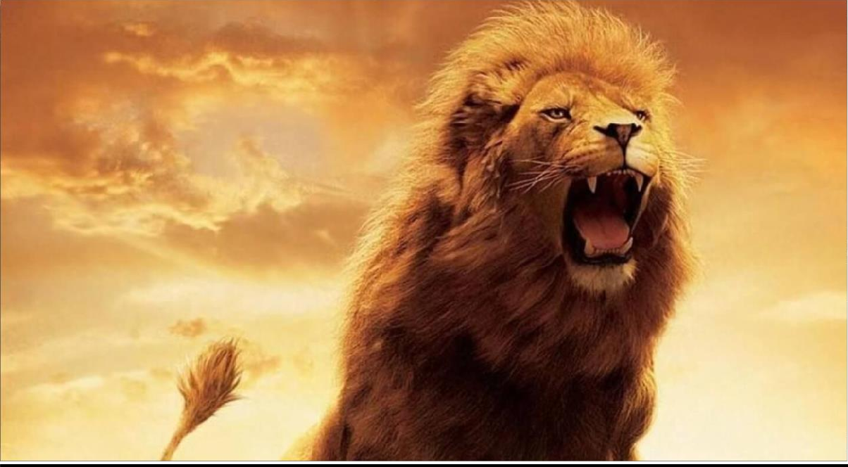

**Sample output :**

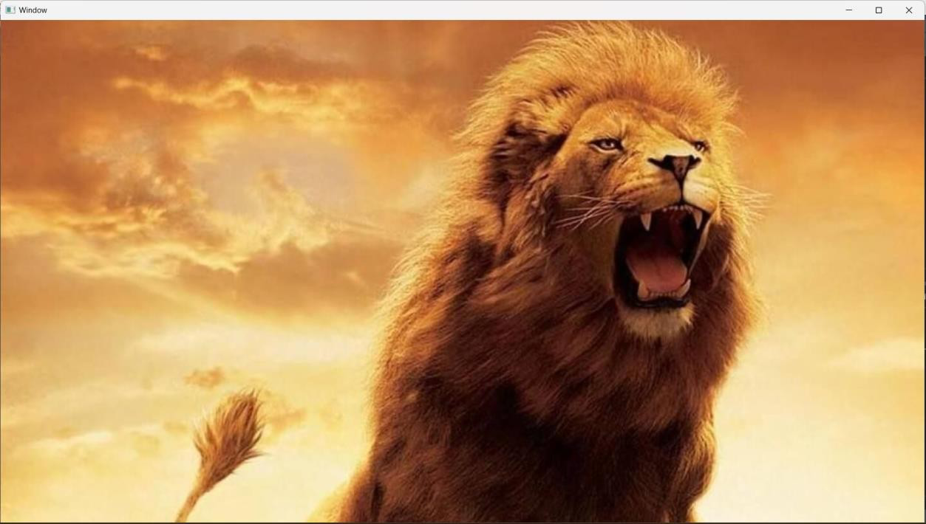

## Result :

Program executed successfully

# Experiment No : 7

## Display the image using OpenCV in python.

**Aim :** To create a python program code to displaying an image using openCV.

## Algorithm :

Step 1 : Import CV2 module in the program code to use all OpenCV function.

Step 2 : Read an image using the imread() function.

Step 3 : Displaying the image using the CV2.imshow() function. Step 4 : waits for user to press any key by using CV2.waitkey(0)

function .

Step 5 : Use CV2 destroyAllWindows() function for closing all open windows.

**Some useful Commmands**

CV2.imread() CV2.imshow() CV2.waitKey() CV2.destroyAllWindows() CV2.split()

CV.imwrite() CV2.cutcolor() CV2.resize() CV2.merge()

### Program code :

import cv2

# Load image

img = cv2.imread(r'C:\Users\amank\OneDrive\Desktop\LION.jpg")

# Display image cv2.imshow("window", img) cv2.waitKey(0) cv2.destroyAllWindows()

### Sample Input :

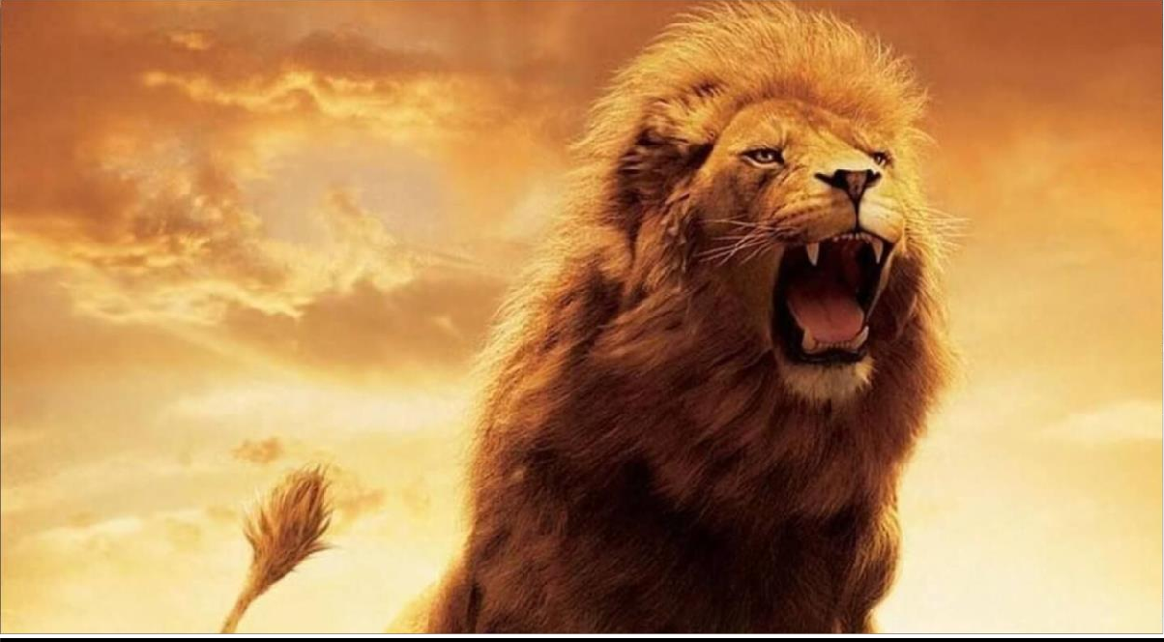

**Sample output :**

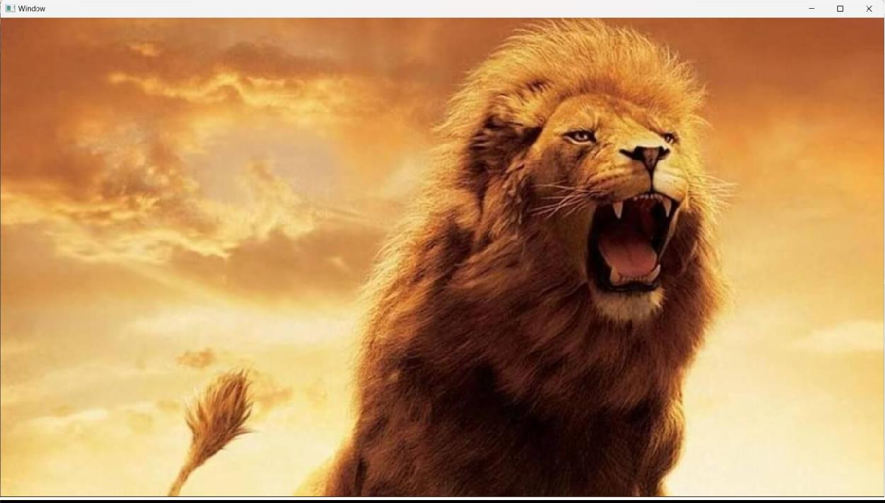

## Result :

Program is executed successfully

# Experiment No : 8

## Write an image using OpenCV in Python.

**Aim :** To create a python Program code to writing an image using OpenCV

## Algorithm :

**Step 1 : import** CV2 module in the program code to use all OpenCV function.

**Step 2 :** import OS module in the program code

**Step 3 :** Assigned the source image directory as a raw string value to the variable (“download.jpg”)

**Step 4 :** Using an CV2 .imread() function () , it reads the image.

**Step 5 :** Change the current directory to specified directory using os.chdis() function.

**Step 6 :** List all files available in the destination directory by using os.list.dis() function.

**Step 7 :** Securing the image by using CV.imwrite() function.

**Step 8** : List all files in the destination directory after saved the

image by using by using os.listdis() function.

## Some useful commands

CV2.imread() CV2.imshow() CV2.waitKey() OS.chdis() OS.listdis() CV2.imwrite() CV2.merge() CV2.split() CV2.cutcolor() CV2.resize()

## Program Code :

import cv2 import os

image_path = (r“C:\user\User\Gaurav\Desktop\CV\puppy.jpg”) directory = (r„C:\Users\nikhil\Desktop\CV)

img = cv2.imread(image_path)

os.chdir(directory)

print("Before saving image:") print(os.listdir(directory))

filename = 'savedImage.png'

cv2.imwrite(filename, img)

print("After saving image:") print(os.listdir(directory))

print('Successfully saved')

## Sample input :

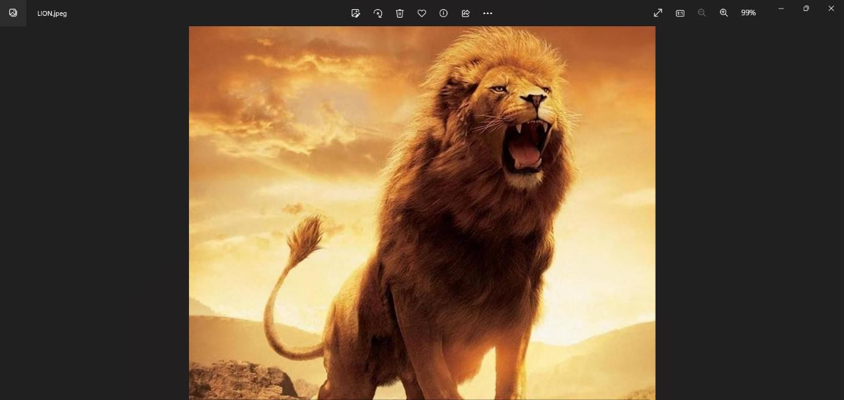

**Sample output :**

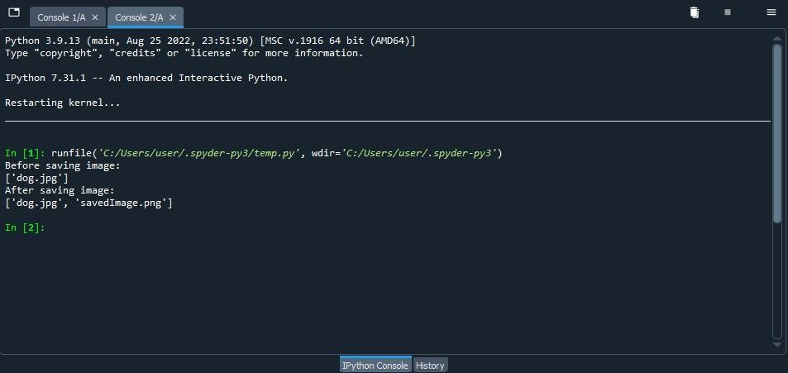

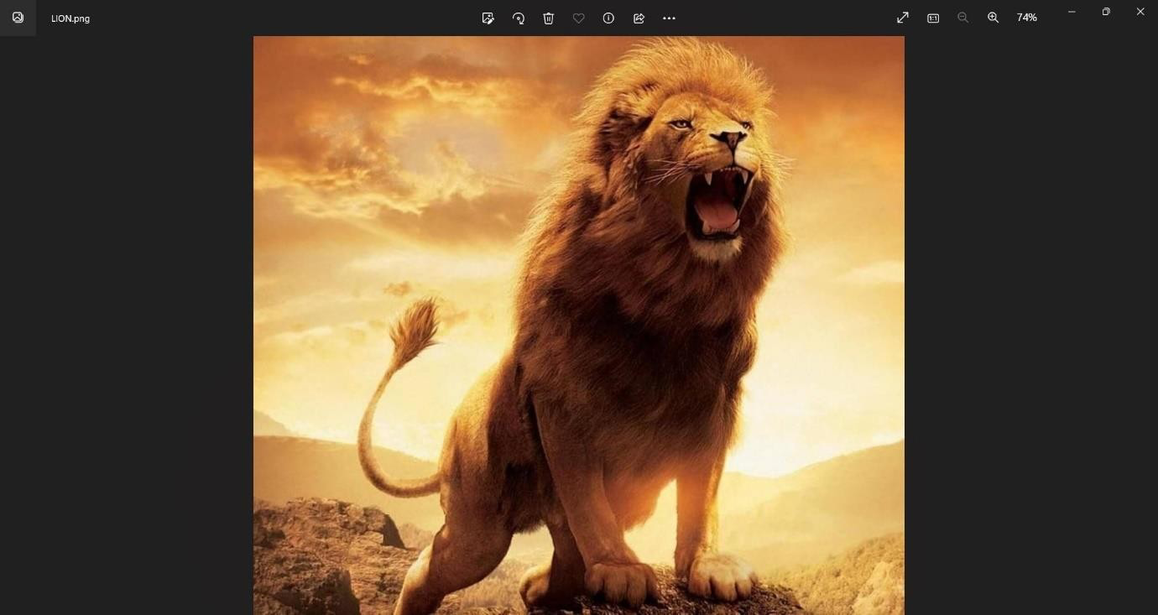

## Result :

Program is executed successfully

# Experiment No : 9

## Splitting and Merging Channels using OpenCV in Python.

**Aim :** Splitting and Merging Channels using OpenCV in Python**.**

## Algorithm :

**Step1 :** Import the required libraries

**Step2 :** Load an image using the cv2.imread() function

**Step3 :** Split the image into its three color channels using the cv2.split() function

**Step4 :** Merge the three color channels back together using the cv2.merge() function

**Step5 :** Display the original image and the merged image using the cv2.imshow() function

**Step6 :** Wait for a key press before closing the windows using the cv2.waitKey() function

**Step7 :** Close all windows using the cv2.destroyAllWindows() function:

## Some useful commands :

Cv2.split() Cv2.imread() Cv2.merge() Cv2.imshow() Cv2.waitkey()

cv2.destroyAllWindows()

## Program Code :

import cv2

import numpy as np

img = cv2.imread(r'C:\Users\user\Desktop\rgb.jpg') b, g, r = cv2.split(img)

cv2.imshow('green channel',g) cv2.imshow('red channel', r) cv2.imshow('blue channel', b) merged = cv2.merge([b, g, r]) cv2.imshow('merged image', merged) cv2.waitKey(0) cv2.destroyAllWindows()

## Sample input :

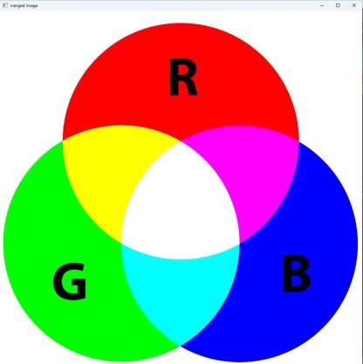

**Sample output :**

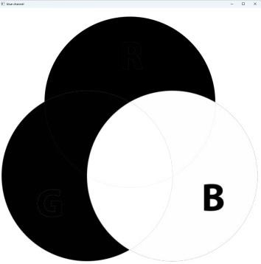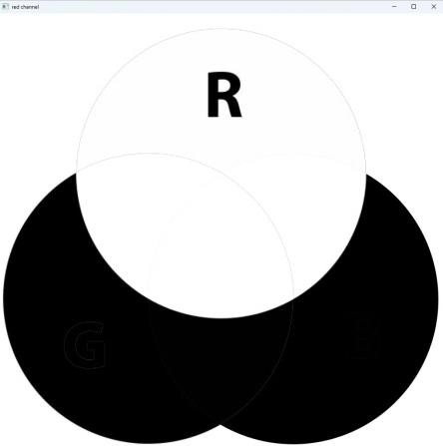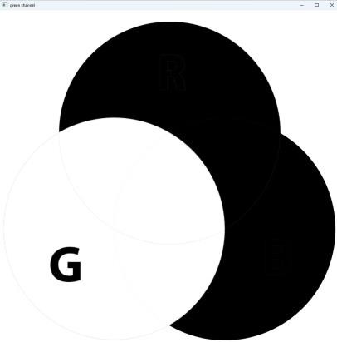

## Result :

Program executed successfully

# Experiment No : 10

## Write a python code to resize an image in opencv using python

**Aim :** To create a python program to resize an image in openCV using python.

## Algorithm :

**Step 1:** Import the necessary packages.

**Step 2 :** Read the image using the cv2.imread() function.

**Step 3 :** Define the new width and height of image.

**Step 4 :** Resize the image using the cv2.resize() function.

**Step 5 :** Display the original and resized image using the cv2.imshow() function.

**Step 6 :** Save the resized image using the cv2.imwrite() method.

## Some useful commands :

import cv2 img=cv2.imread() print()

dim=() resize=cv2.resize() cv2.imshow() cv2.waitKey()

cv2.destroyAllWindows()

## Program code :

import cv2

img = cv2.imread(r“C:\user\User\aman\Desktop\lion.jpg”) cv2.imshow(„original Image‟,img)

resized_img = cv2.resize(img,(300,300)) cv2.imshow(„Resized Image‟,resized_img) cv2.waitKey(0)

cv2.destroyAllWindows()

## Sample input :

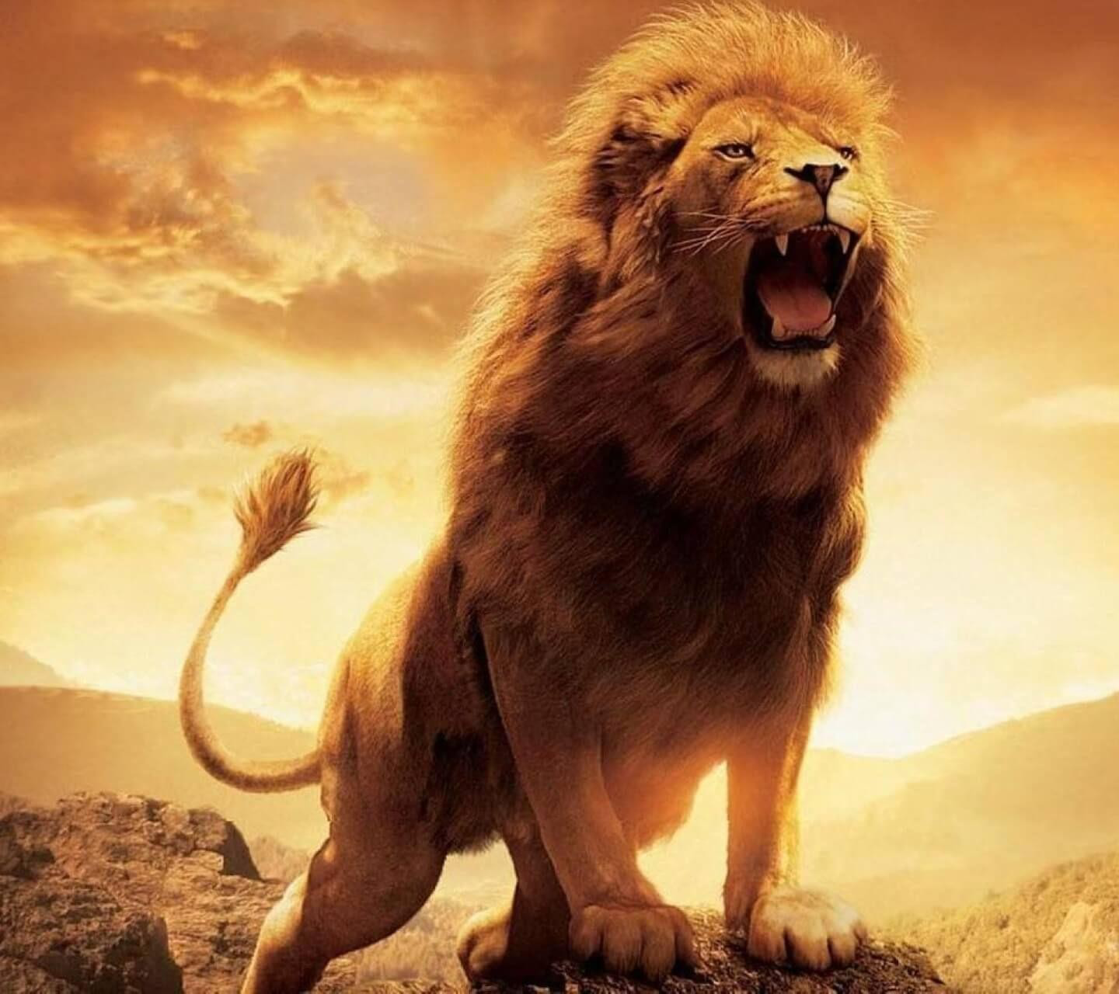

**Sample Output :**

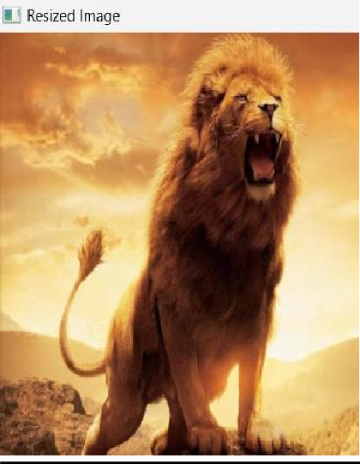

## Result :

Program executed successfully

# Experiment No : 11

## To convert image jpg to png format using OpenCV in Python.

**Aim** : To create a python program to convert image jpg to png format in open cv using python.

## Algorithm :

**Step 1:** Load the image in use the „imread()‟ function to load the image from the file system.

**Step 2:** Convert the image in use the „cv2.imwrite() function to convert the **i**mage to png format and save it to disk

**Step 3:** This function takes two arguments the output filename and image object.

## Some useful commands :

import cv2

image cv2.imread() cv2 . imwrite() cv2.waitkey()

cv2.destroyAllWindows()

### Program code :

import cv2

src = cv2.imread(r“C:\user\User\Gaurav\Desktop\CV\dog.jpg”)

cv2.imwrite(r“C:\user\User\Gaurav\Desktop\CV\savedImage.png”, src)

cv2.waitKey(0) cv2.destroyAllWindows() **Sample input :**

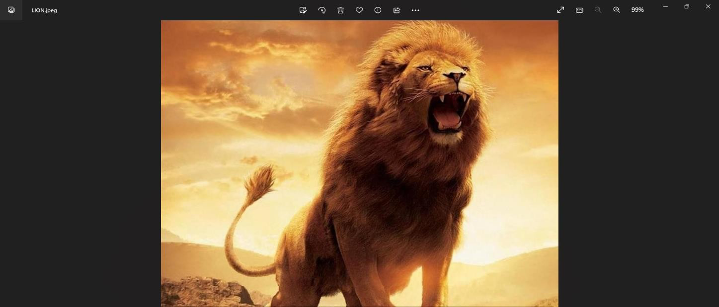

**Sample output :**

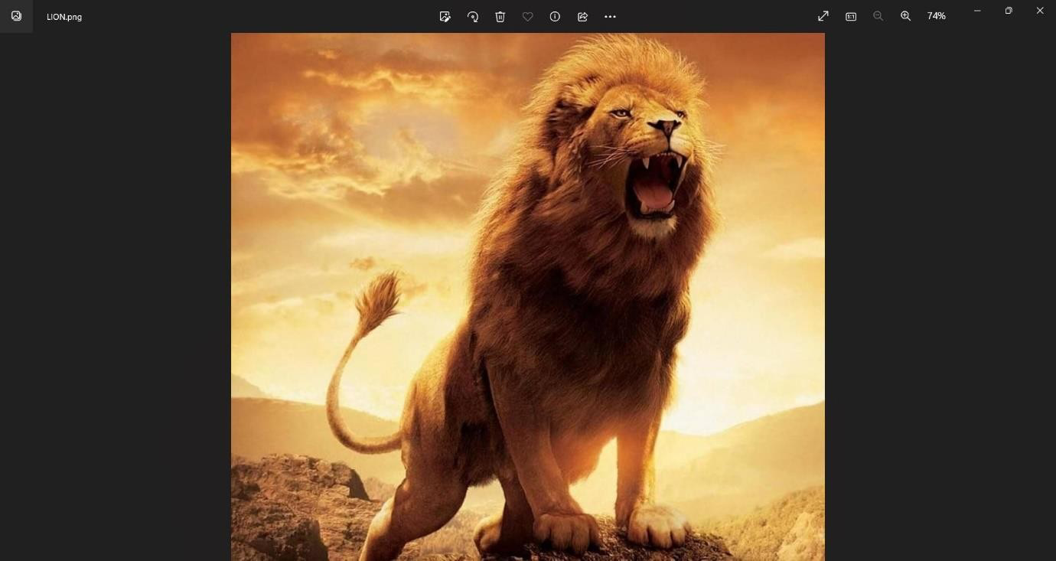

## Result :

Program executed successfully

# Experiment No : 12

Write a python code to convert a coloured image into a grayscale image using opencv

## Aim :

To create a python program to convert a coloured image into a Grayscale image using opencv.

**Algorithm :**

**Step 1 :** Import the necessary libraries „numpy‟ and „cv2 „.

**Step 2 :** Load the coloured image using the „cv2.imread()‟ function.

**Step 3 :** Convert the coloured image to grayscale using the

„cv2.cvtcolor()‟ function. This function converts an image from one color space to another.

**Step 4 :** Display the coloured image using the „cv2.imshow()‟ function.

**Some useful commands:-**

Import cv2

Image = cv2.imread() cv2.imshow()

gray _image = cv2.cvt Color() cv2.waitKey() cv2.destroyAllWindows()

**Program code :**

import cv2

# Load the image

img = cv2.imread(r'C:\Users\amank\OneDrive\Desktop\LION.jpg')

# Convert the image into grayscale

gray_img = cv2.cvtColor(img, cv2.COLOR_BGR2GRAY)

# Display the original and grayscale image cv2.imshow('original Image', img) cv2.imshow('Grayscale Image', gray_img) cv2.waitKey(0)

cv2.destroyAllWindows()

**Sample Input :**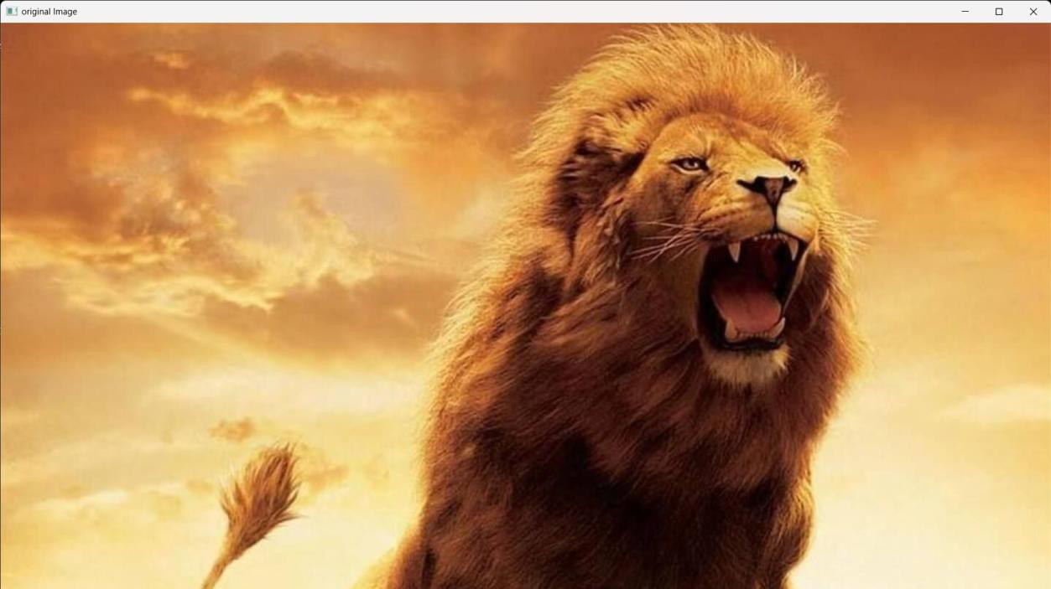

**Sample Output :**

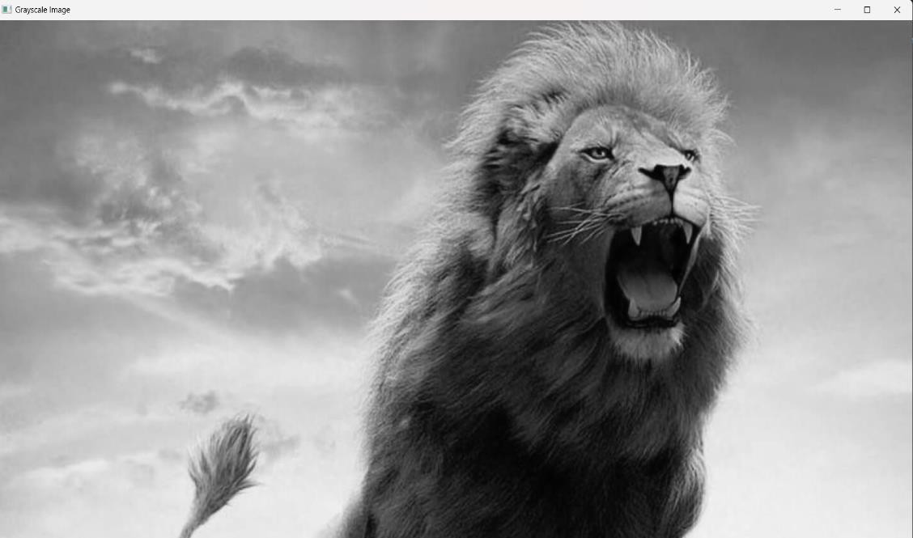

**Result:** Program executed successfully

# Experiment No : 13

Play a Video in OpenCV using Python

**Aim:** To create a python program using the opencv module to play a video.

## Algorithm:

**Step1 :** Import the necessary modules, including cv2 (the OpenCV module) and numpy (for numerical processing).

**Step2 :** Create a VideoCapture object to capture the video file.

This can be done by passing the path of the video file to the constructor of the VideoCapture class.

**Step3 :** Check if the VideoCapture object was created successfully by using the isOpened() method.

**Step4 :** If 0the VideoCapture object was created successfully, start a while loop to read and display the frames of the video.

**Step5 :** Use the read() method to read the next frame of the video.

**Step6 :** Check if the frame was read successfully by checking if the return value of read() is True.

**Step7 :** If the frame was read successfully, display the frame using imshow() method.

**Step8 :** Wait for a specified amount of time using waitKey() method.

**Step9 :** Exit the while loop if the end of the video is reached or the user presses the 'q' key.

**Step10 :** Release the VideoCapture object and close all windows using release() and destroyAllWindows() methods respectively.

## Some useful commands :

import cv2

video = cv2.videoCapture() cv2.imshow() video.release() cv2.destroyAllWindows()

### Program code :

import cv2

# Load the video file

video_path = (r'C:\Users\user\Downloads\car.mp4') cap = cv2.VideoCapture(video_path)

# Check if the video was successfully loaded if not cap.isOpened():

print("Error opening video file") # Start the video playback

while cap.isOpened():

# Read the frame from the video ret, frame = cap.read()

# Check if the frame was successfully read

if not ret: break

# Display the frame cv2.imshow('Video', frame)

# Wait for 25 milliseconds and check if the user pressed the 'q' key to quit

if cv2.waitKey(25) & 0xFF == ord('q'): break

# Release the video capture object and destroy all windows cap.release()

cv2.destroyAllWindows()

**Sample Output :**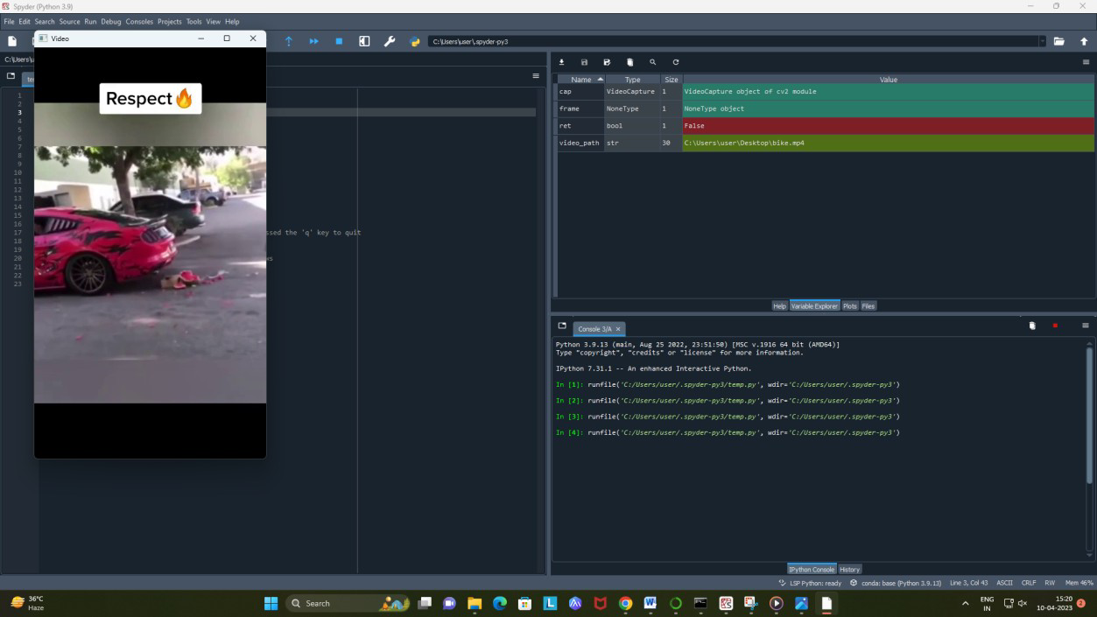

### Result :

Program executed successfully

# Experiment No : 14

Extract image from video using OpenCV in Python**.**

**Aim:** To create a python program to extract images from Video.py

## Algorithm:

**Step1 :** Import the necessary libraries.

**Step2 :** Set the file path for the video and create a video Capture Object.

**Step3 :** Check if the video was opened successfully.

**Step4 :** Get the number of frames in the video.

**Step5 :** Choose a frame number to extract. For example, to extract the first frame

**Step6 :** Set the frames position to the chosen frame number.

**Step7 :** Read the frame at the chosen frame number.

**Step8 :** Check if the frame was read successfully.

**Step9 :** Save the frame as an image.

**Step10:** Release the video Capture object.

## Some useful commands:

import cv2

video = cv2.videoCapture() filename = “image {}.jpg”.format() cv2.imwrite()

video.release()

## Program code:

### import cv2

cap = cv2.VideoCapture(r'C:\Users\nikhil\Downloads\5sec.mp4') frame_count = 30

while cap.isOpened(): ret, frame = cap.read() if ret == True:

frame_count += 60

cv2.imwrite(r'C:\Users\nikhil\Desktop\frame_{}.jpg'.format(frame_co unt), frame)

else:

break

cap.release() cv2.destroyAllWindows()

### Sample input :

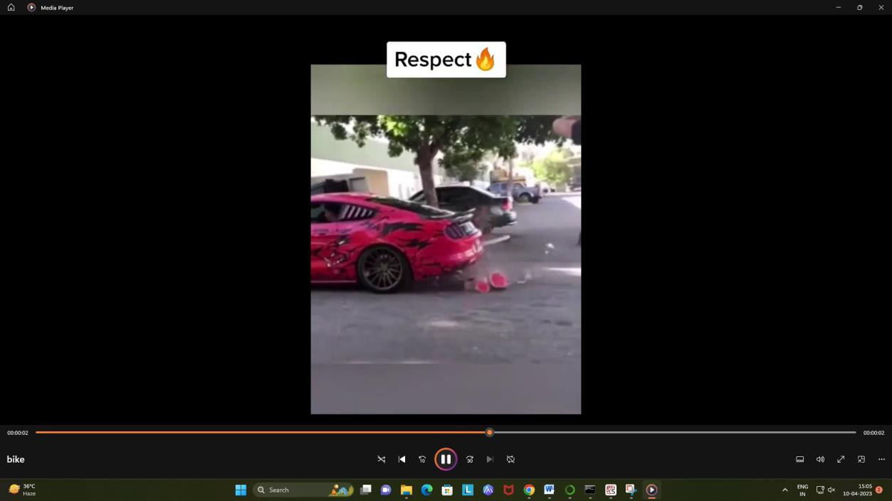

**Sample output :**

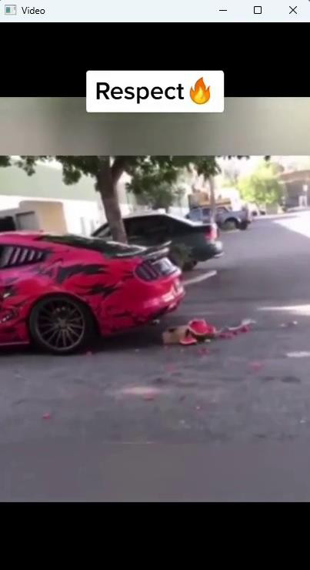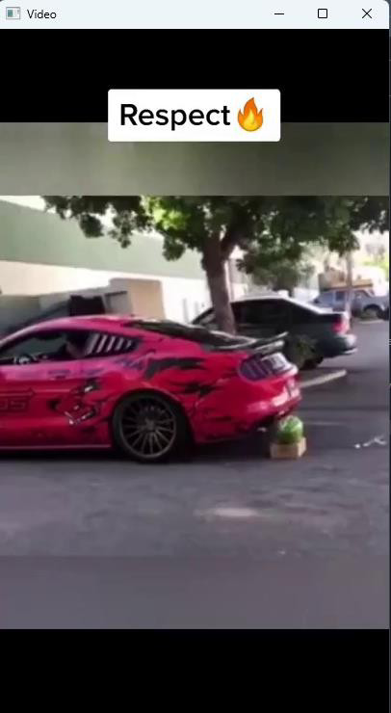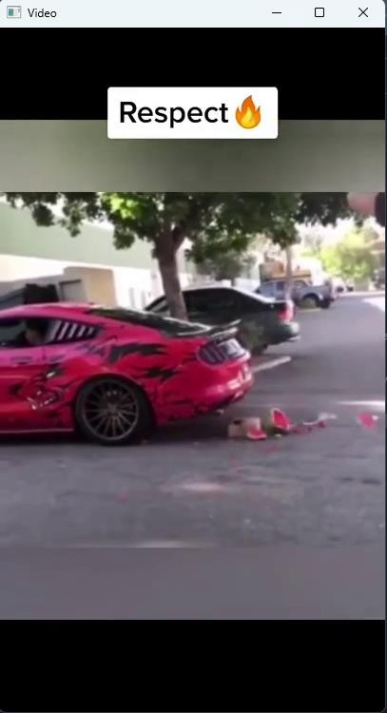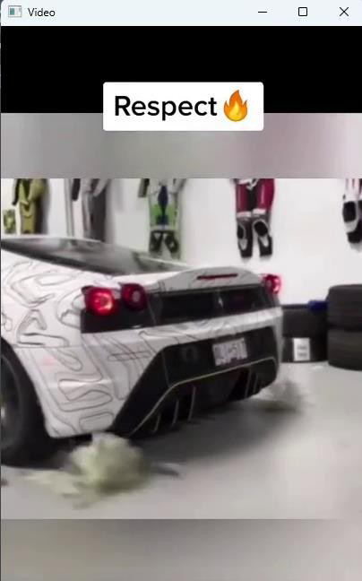

### Result :

Program executed successfully

# Experiment No : 15

Write a python code using open cv module for all the geometric transformation of image.

**Aim:** To create a python program using opencv module for all the geometric transformation.

## Algorithm :

**Step1 :** Import the necessary modules.

**Step2 :** Load the image.

**Step3 :** Define the transformation matrix.

**Step4 :** Apply the transformation to the image.

**Step5 :** Display the original and transformed image.

## Some useful commands :

Import cv2 Import numpy cv2.imshow() Cv2.imread() Cv2 .resize Cv2.flip

cv2.getRotationMatrix2D cv2.warpAffine cv2.waitKey() cv2.destroyAllWindows()

## Program code :

import cv2

import numpy as np

img = cv2.imread(r"C:\Users\user\Desktop\lion.jpg")

# Resizing

resized = cv2.resize(img, (400, 400))

# Flipping

flip_horizontal = cv2.flip(img, 1) flip_vertical = cv2.flip(img, 0) flip_both = cv2.flip(img, -1)

# Rotation

(rows, cols) = img.shape[:2]

M = cv2.getRotationMatrix2D((cols/2, rows/2), 45, 1) rotated = cv2.warpAffine(img, M, (cols, rows))

# Affine transformation

pts1 = np.float32([[50, 50], [200, 50], [50, 200]])

pts2 = np.float32([[10, 100], [200, 50], [100, 250]])

M = cv2.getAffineTransform(pts1, pts2) affine_transformed = cv2.warpAffine(img, M, (cols, rows))

# Perspective transformation

pts1 = np.float32([[56, 65], [368, 52], [28, 387], [389, 390]])

pts2 = np.float32([[0, 0], [300, 0], [0, 300], [300, 300]])

M = cv2.getPerspectiveTransform(pts1, pts2) perspective_transformed = cv2.warpPerspective(img, M, (300, 300))

# Display the original and transformed images

cv2.imshow("Original", img) cv2.imshow("Resized", resized) cv2.imshow("Horizontal flip", flip_horizontal) cv2.imshow("Vertical flip", flip_vertical) cv2.imshow("Both flip", flip_both) cv2.imshow("Rotated", rotated)

cv2.imshow("Affine transformed", affine_transformed) cv2.imshow("Perspective transformed", perspective_transformed)

# Wait for a key press and close all windows cv2.waitKey(0)

cv2.destroyAllWindows()

## Sample input:

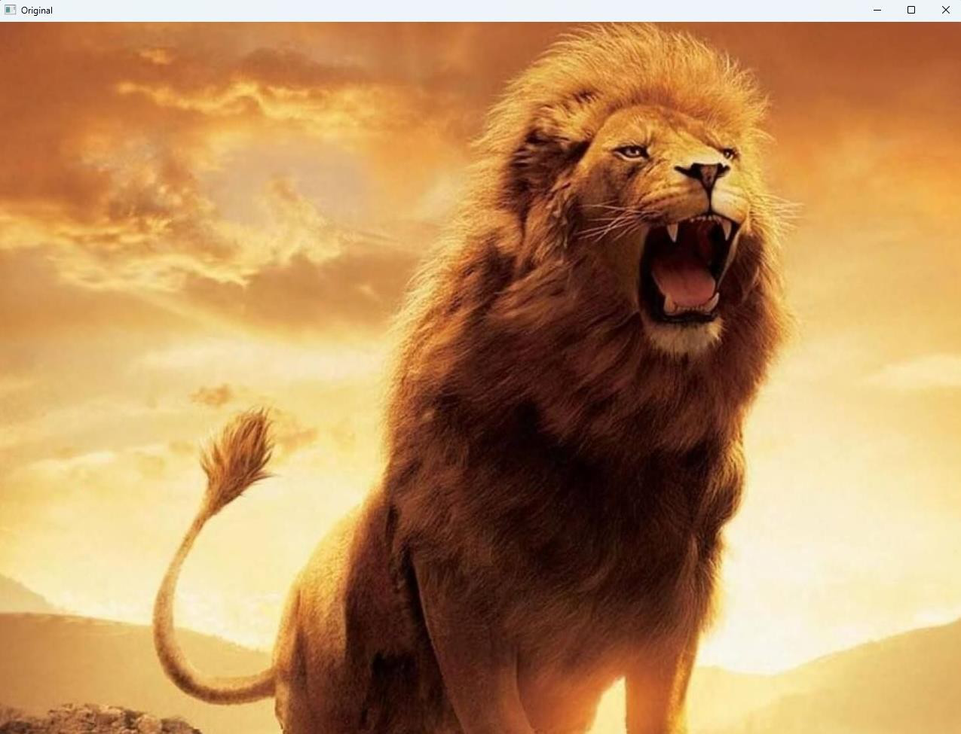

**Sample output:**

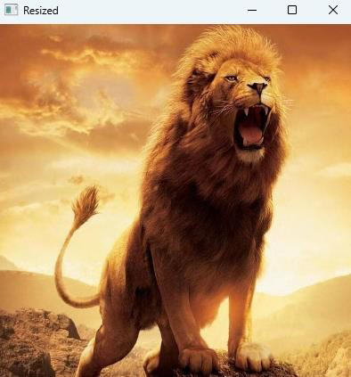

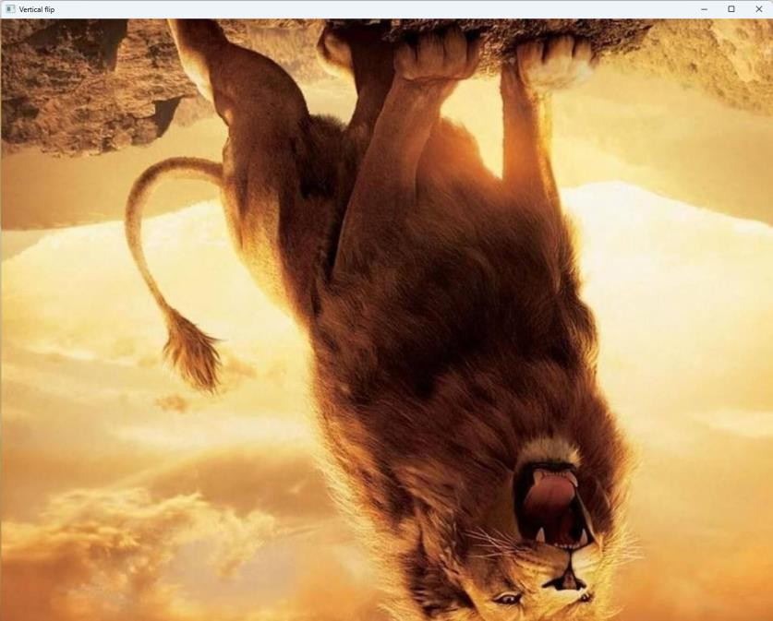

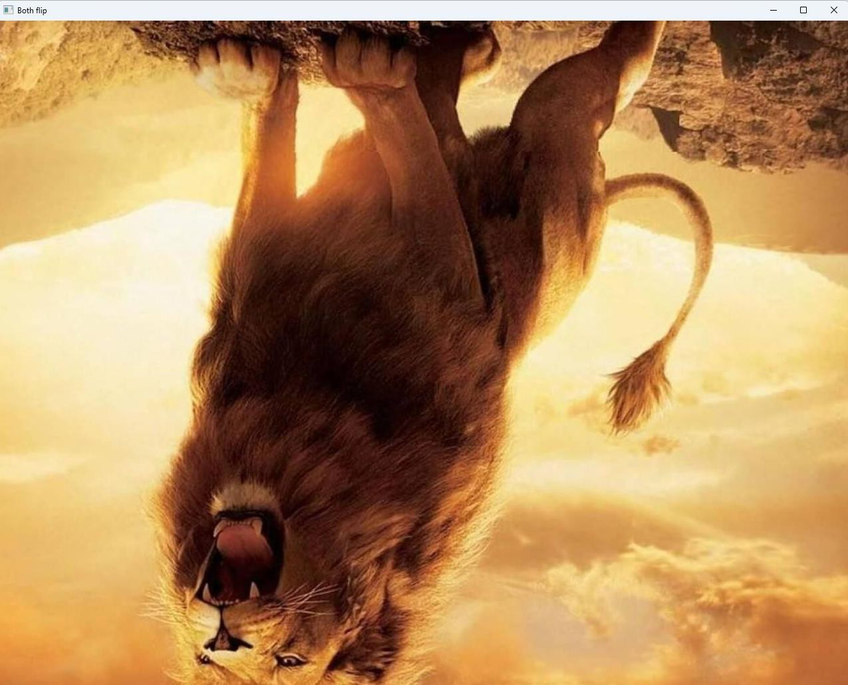

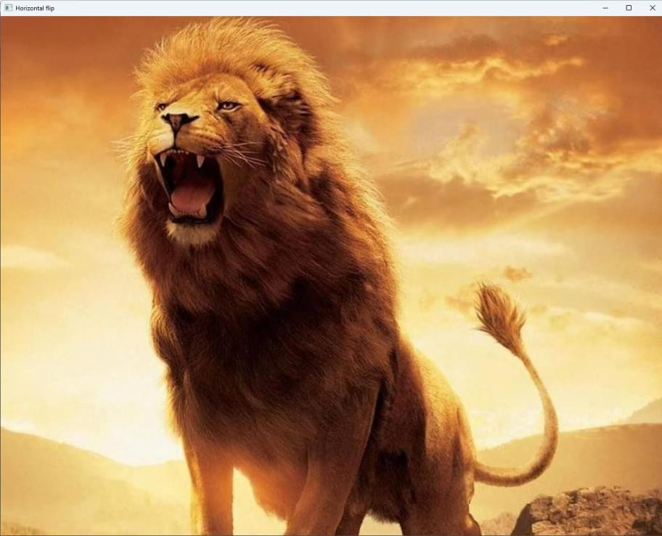

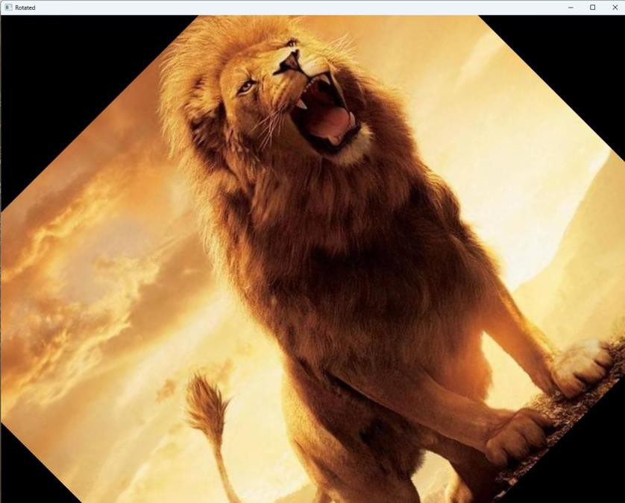

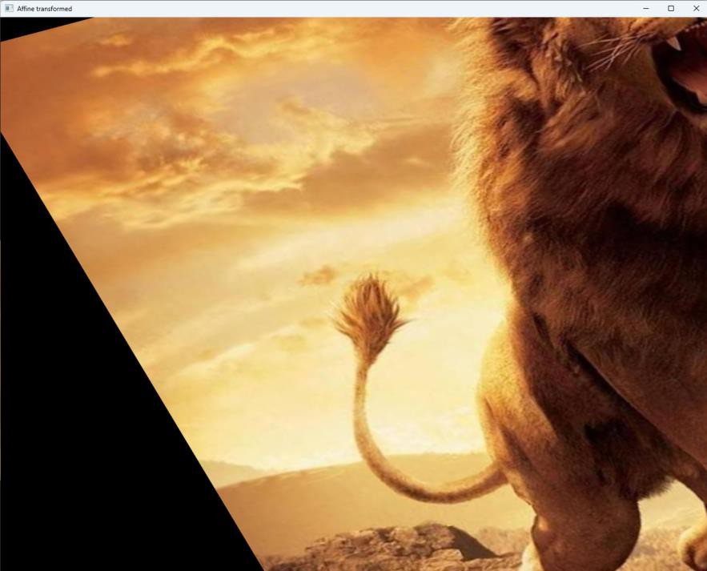

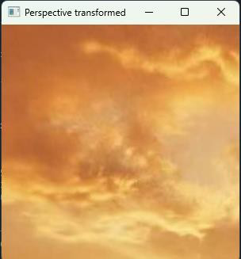

## Result :

Program executed successfully

# Experiment No : 16

Write a program for 3 compute homography transformation.

**Aim :** To compute the homography transformation between two images, which can be used to warp one image onto the other.

## Algorithm:

**Step1 :** Load the two images.

**Step2 :** Detect keypoint features in both images using a feature detection algorithm such as SIFT or ORB.

**Step3 :** Extract the descriptors for the keypoint features.

**Step4 :** Match the keypoint features between the two images using a feature matching algorithm such as Brute-Force Matching or FLANN (Fast Library for Approximate Nearest Neighbors) matching.

**Step5 :** Use the matched keypoint features to compute the homography transformation matrix using the RANSAC algorithm (Random Sample Consensus).

**Step6 :** Apply the homography transformation to warp one image onto the other.

## Useful Commands:

cv2.imread() cv2.cvtColor() cv2.drawMatches() cv2.findHomography() cv2.warpPerspective()

## Program code:

import cv2

import numpy as np

img1 = cv2.imread(r"C:\Users\nikhil\Desktop\CV\dog.jpg") img2 = cv2.imread(r"C:\Users\nikhil\Desktop\CV\puppy.jpg") sift = cv2.xfeatures2d.SIFT_create()

kp1, des1 = sift.detectAndCompute(img1, None) kp2, des2 = sift.detectAndCompute(img2, None) matcher = cv2.BFMatcher()

matches = matcher.match(des1, des2)

pts1 = np.float32([kp1[m.queryIdx].pt for m in matches]).reshape(-1, 1, 2)

pts2 = np.float32([kp2[m.trainIdx].pt for m in matches]).reshape(-1, 1, 2)

H, _ = cv2.findHomography(pts1, pts2, cv2.RANSAC, 5.0)

aligned_img = cv2.warpPerspective(img1, H, (img2.shape[1], img2.shape[0]))

cv2.imshow('Aligned Image', aligned_img) cv2.waitKey(0)

cv2.destroyAllWindows()

## Sample input:

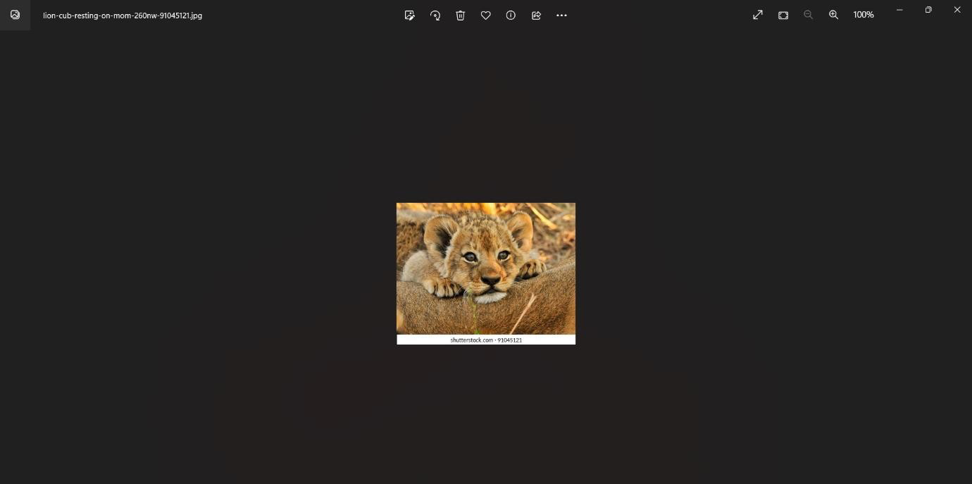

**Sample Output :**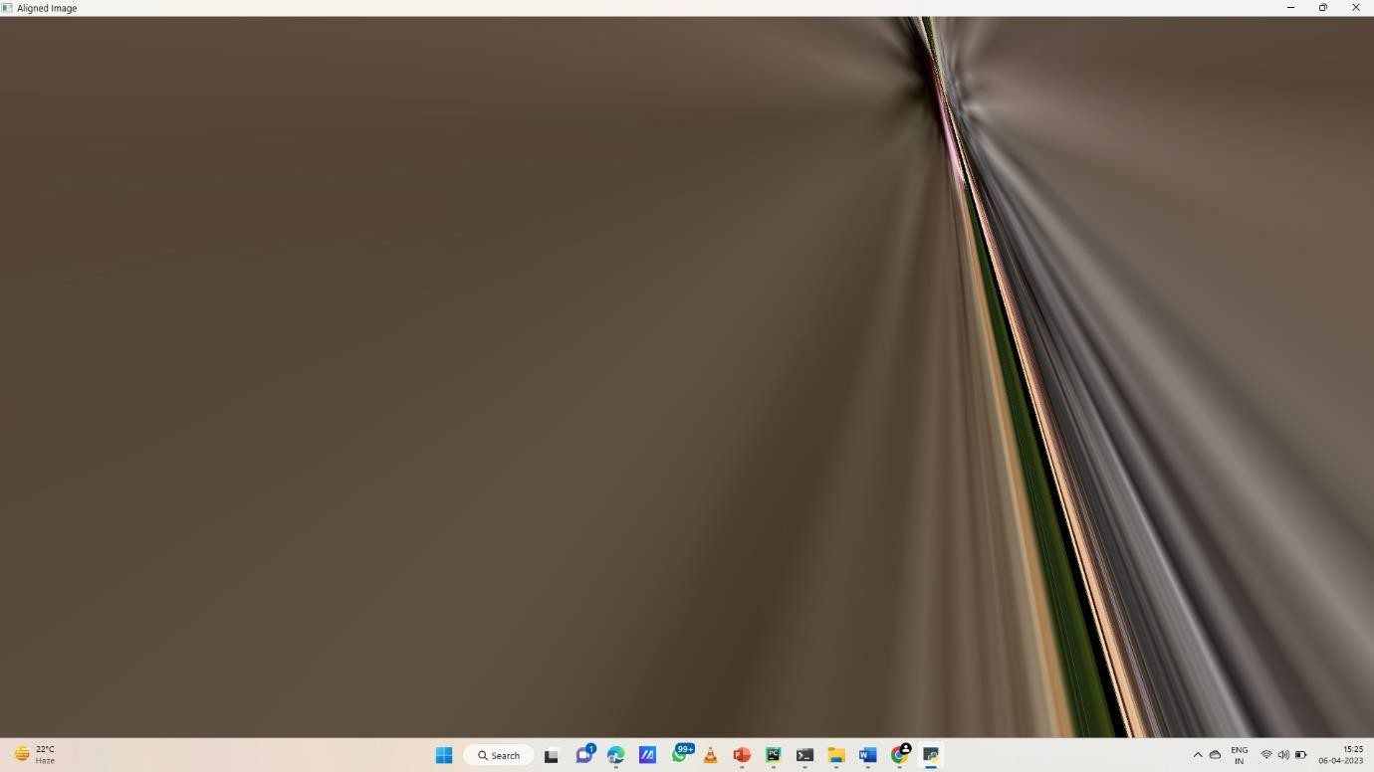

## Result:

Program executed successfully